1. **Installing and loading packages**

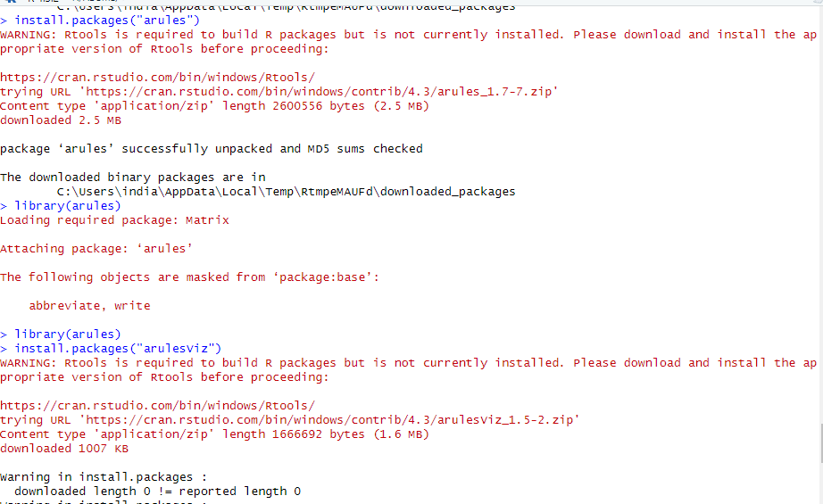

1. **Read and view dataset csv file**



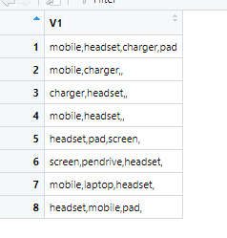











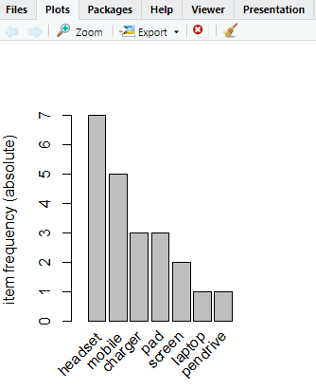









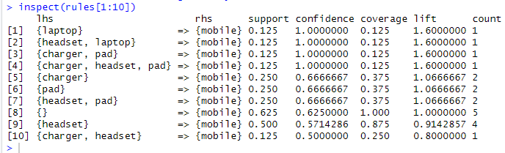

**7 Plotting Graph**



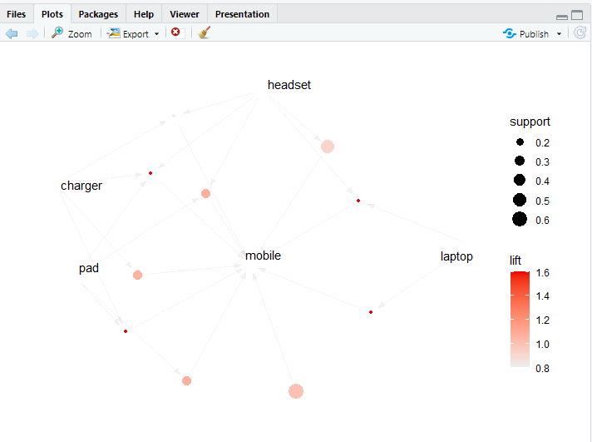

**Exercises:**

**Write a program to perform market basket analysis on Groceries dataset and display the top 5 important rules after sorting by confidence.**

> Groceries <-read.csv(“groceries.csv”)

